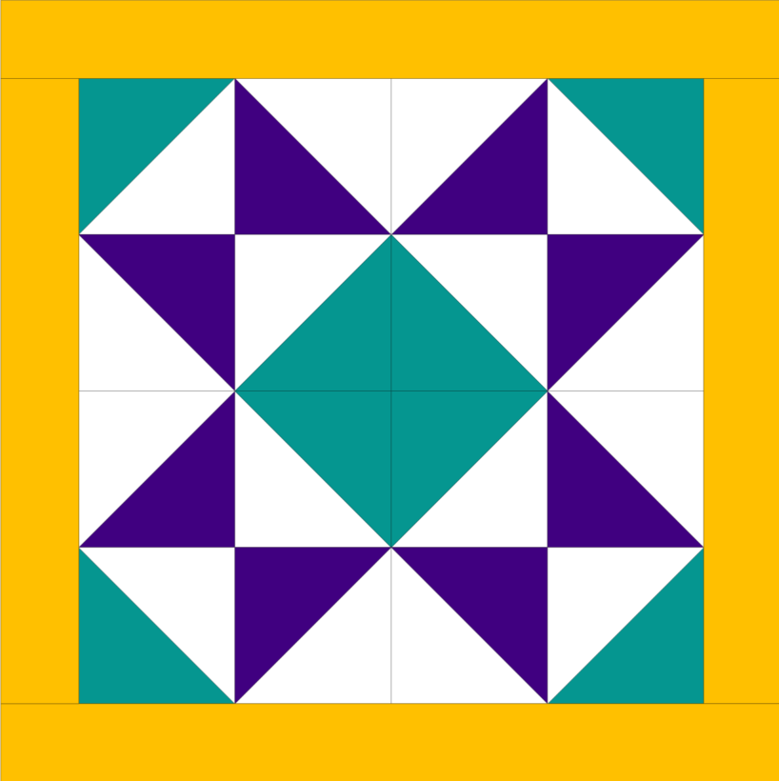
Difficulty Level: Beginner
Finish Pillow Size: 20" x 20"
Fabric shown: Kona Cotton by Robert Kaufman

New to quilting? This is a great way to get your feet wet. In this pattern, we'll use a shortcut to make many half-square triangles (HST) fast. Once they are done, there are loads of ways to put them together. Feel free to play with the orientation to make your own design.

Requirements:

Quilt top fabric:
  - One 10-inch square - primary color
  - One 10-inch square - secondary color
  - Two 10-inch squares background color
  - Two 2 ½ x 20 ½ -inch strips
  - Two 2 ½ x 18 ½ -inch strips

Backing:
  - Two 20 ½ x 15-inch rectangles

Instructions:
- Mark the background squares Draw two diagonal lines from corner to corner on each of the backs of the fabric.
- Take one background square and place it on top of the primary color squares, with the pretty sides of the fabric touching each other.
- Sew ¼ inch from each side of the marked lines.
- Cut the square horizontally and vertically to make 4 squares
- Cut directly on the drawn lines
- Press open each of the triangles with and iron.
- Repeat steps 2-6 with the secondary color fabric.
- Arrange blocks as desired. Here are some suggestions:
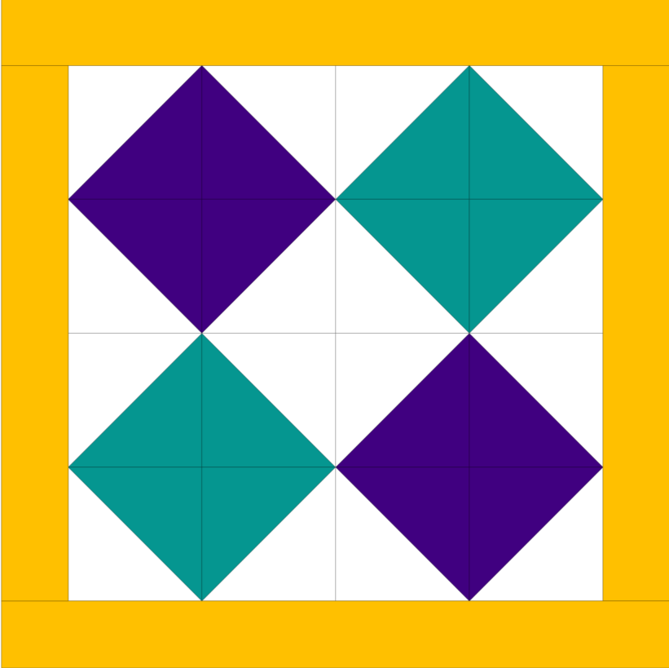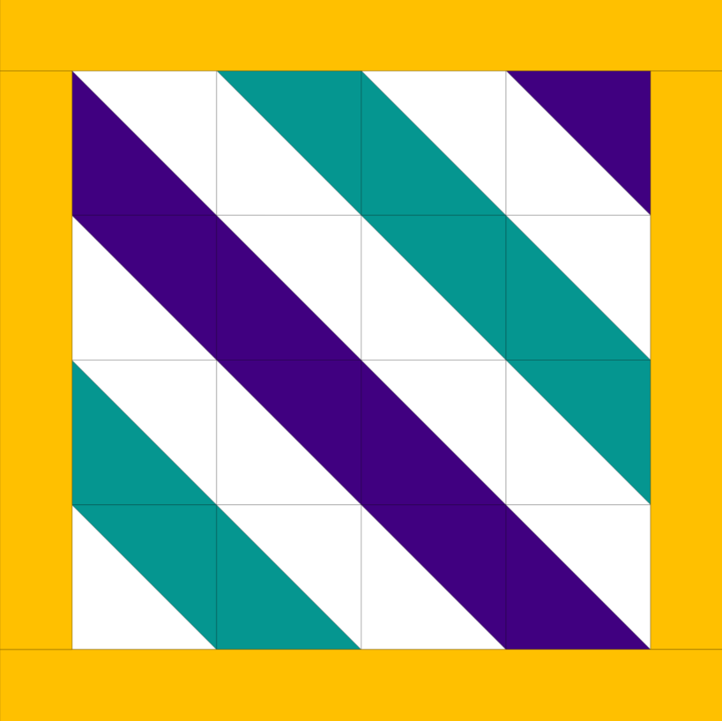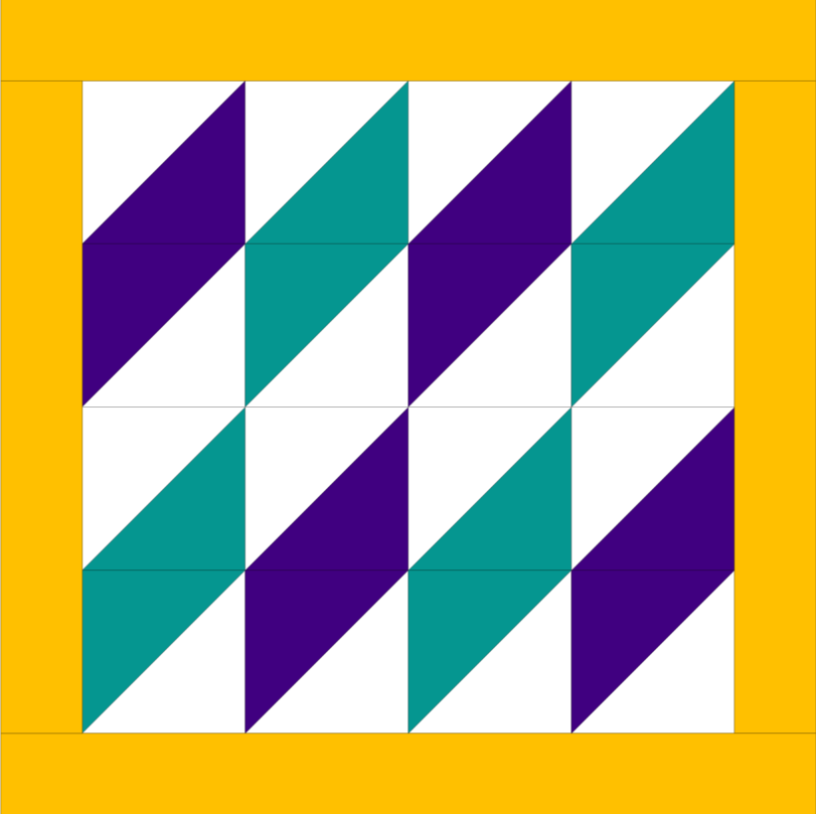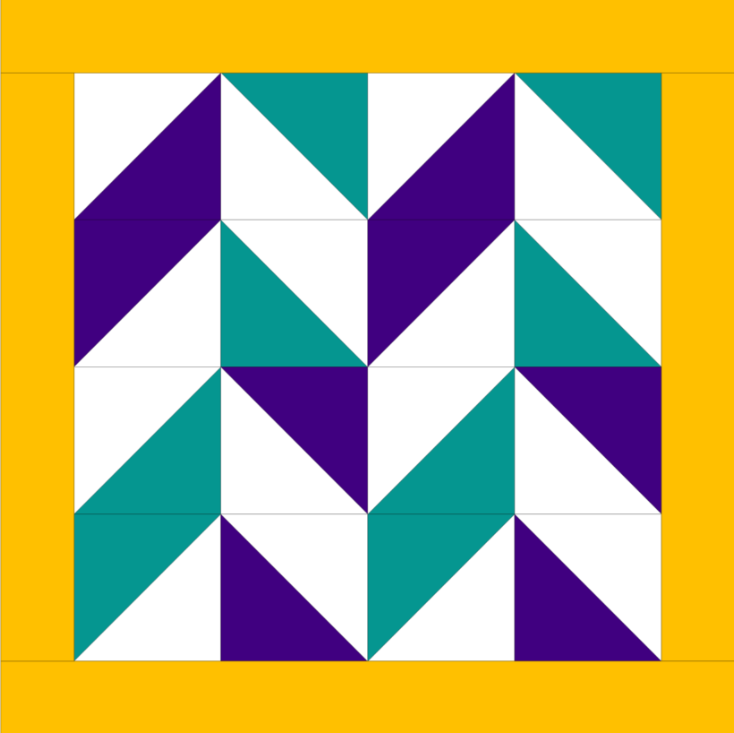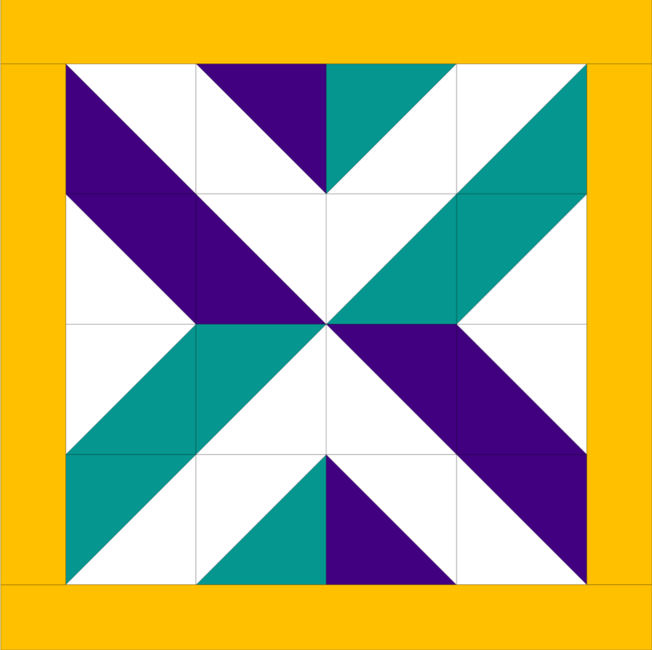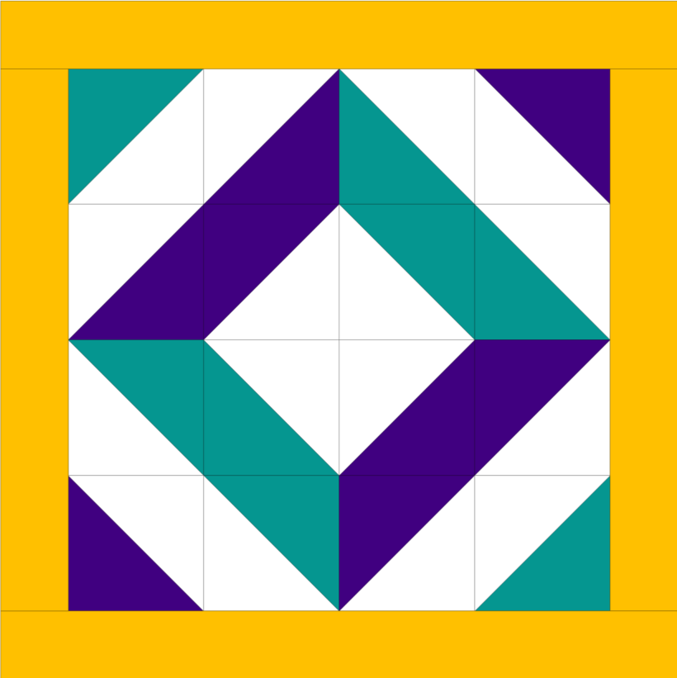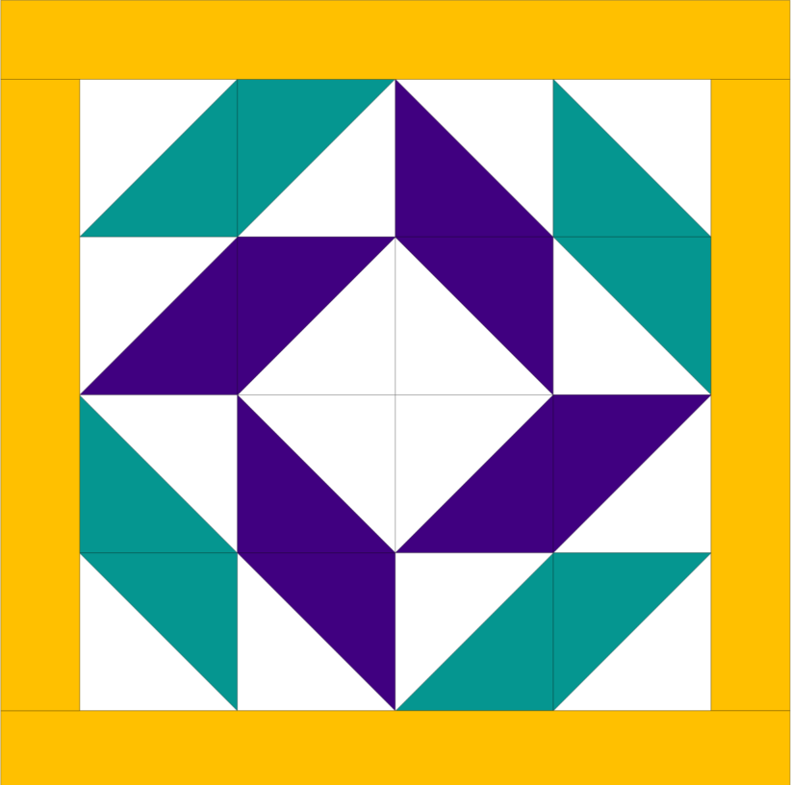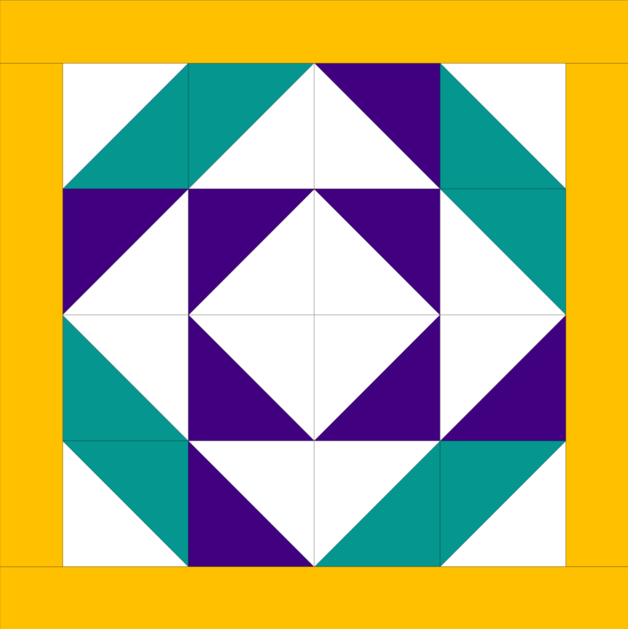

- After you've arranged them as you like, sew each row together with a quarter-inch seam.
- Press the seams from the first and third rows to the right, and the second on fourth rows to the left
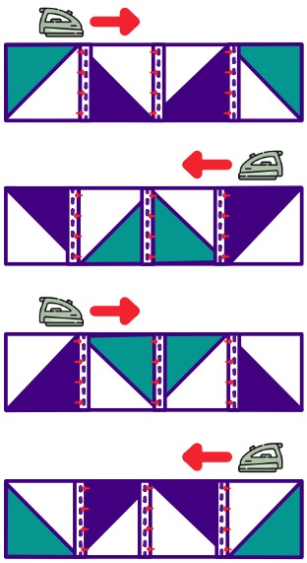
- Snuggle the seams for the first and second rows together so that the seam allowances are touching each other and pin.
- Repeat step 11 with the third and fourth rows.
- Repeat step 11 to finish sewing up the block together.
- Sew the shorter strips on opposite sides of the block.
- Sew the longer strips to the top and the bottom.
- Take the 2 backing pieces and iron back 1/2 inch on the 20 ½ inch side.
- Fold in again and iron down.
- Sew down the hem close to each side of the fold.
- Line up the top and bottom of the block with the background pieces and pin - the background pieces will overlap
- Sew a quarter of an inch around the square.
- Snip the corners of the square and turn right side out.
- Gently poke out the corners and add your pillow.
- Enjoy your new pillow!

